**CONNECTING ANGULAR 4 WITH EXPRESS GENERATOR APP LOCATED IN DIFERENT SERVERS**

REF:

<https://stackoverflow.com/questions/33596646/session-undefined-in-express-when-angularjs-as-frontend>

FIRST IT’S NECCESSARY TO CHANGE CORS CONFIGURATION IN EXPRESS SERVER, AND SPECIFY IP ADDRESS OF OUR FRONT END ANGULAR 4 CLIENT:

***app.js*** FILE

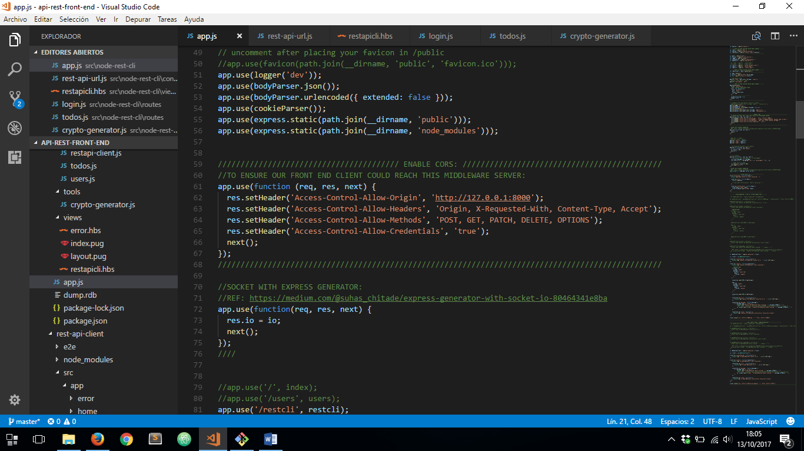

AND IT’S NECESSARY TO SPECIFY ***Access-Control-Allow-Credentiask*** WITH VALUE OF ***true*** TO ENSURE OUR FRONT END CLIENT BE ABLE TO CONNECT TO THIS SERVER.

NOW IN THE FRONT END ANGULAR 4 CLIENT IT’S NECESSARY TO ALWAYS SPECIFY ***withCredentials*** HEADER ON EACH REQUEST TO EXPRESS SERVER:

***login.service.ts***

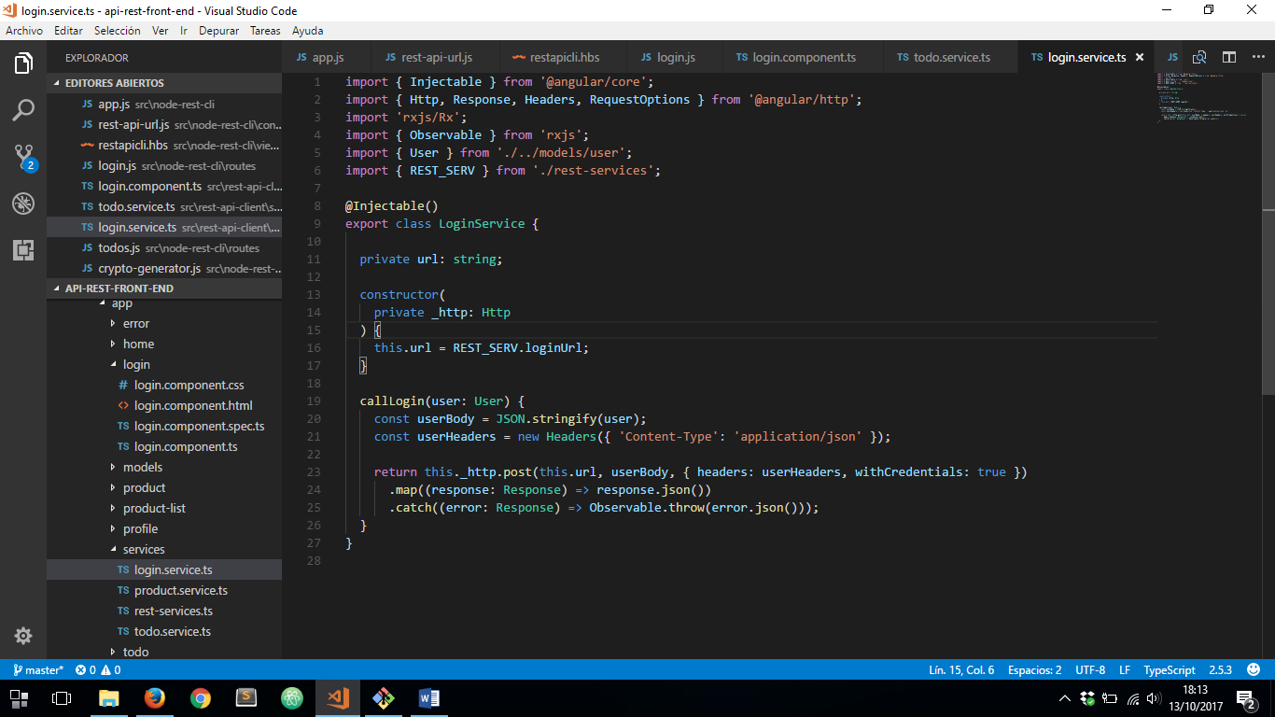

***todo.service.ts***

